**Question One**

**Recommendation One: Target High-Reliance Counties and States**

The analysis of the merged data shows that Vermont, North Dakota, Maine, Montana, and New Hampshire are the top five states with a high contractor reliance, whereas Real, Tripp, Routt, Dukes, and Hot Springs are the top counties with a high contractor reliance. For example, the analysis shows that Vermont has the highest average contractor reliance of 31.56%, while Real County contractor reliance is 100%. In the regard, the high-reliance counties and states encounter staffing shortages and the high full-time employee turnover. As a result, Clipboard Health has the opportunity to provide contracting staffing solutions to these areas.

Firstly, Clipboard Health should focus sales efforts on high-reliance states and counties, especially the top three. It should prioritize sales and outreach initiatives to nursing homes in Vermont, North Dakota, and Maine. For instance, Clipboard Health should establish partnerships with nursing homes or healthcare facilities in Real, Tripp, and Routt to provide customized staffing solutions to address their employee shortage and its brand awareness and presence in the counties. Consequently, Clipboard Health will establish itself as a trusted provider of staff solutions, especially health contractors, in these states and counties.

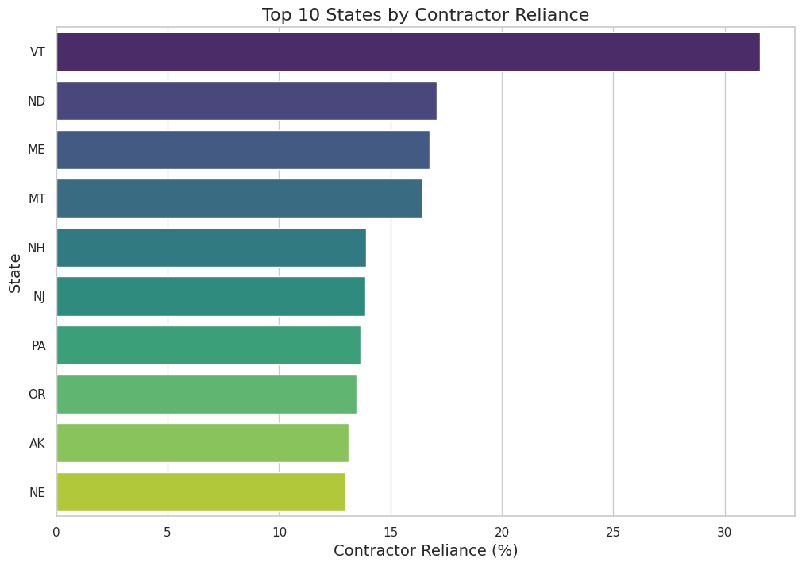

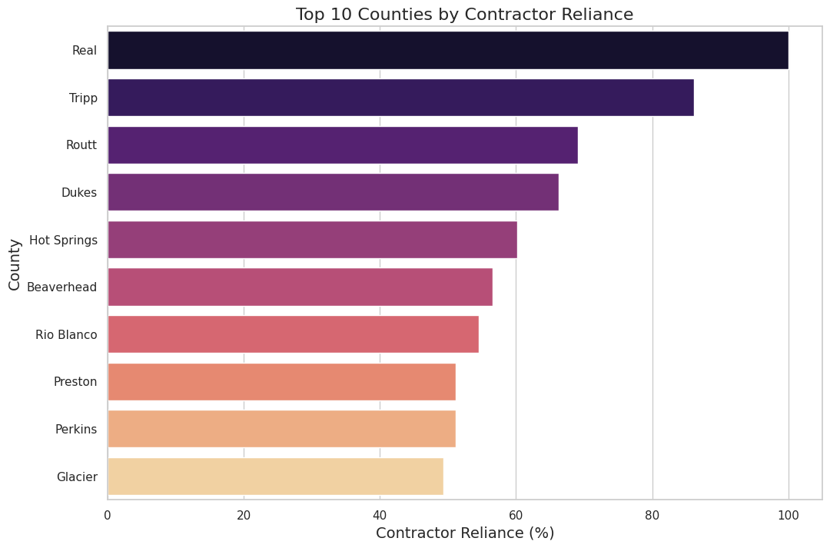

**Recommendation Two: Target Government-Owned and For-Profit Facilities**

The analysis of the merged data shows that government-hospital district and for-profit facilities highly rely on contracted healthcare personnel. In the analysis, 27.85% of government-hospital district facilities highly depend on contracted workers, while 17.50% of for-profit partnerships rely on contracted personnel to provide healthcare services. The challenges of fulltime employee turnover and budget constraints negatively impact the abilities of government-hospital district and for-profit facilities to hire and retain fulltime workers. Thus, Clipboard Health should take advantage of the challenges to target government-hospital district and for-profit facilities.

Notably, Clipboard Health should focus sales efforts on government-hospital district and for-profit facilities, especially in high-reliance states and counties in the first section. The organization should develop targeted campaigns that prioritize cost-effectiveness and reliability staffing solutions to market itself among government-hospital district and for-profit facilities. For example, Clipboard Health should high cost-effectiveness, reliability, and flexibility of its staffing solutions to for-profit facilities’ partnerships and LLCs. The company should provide customized staffing packages that address the distinct employees' needs of government-hospital district and for-profit facilities. Consequently, Clipboard Health will establish itself as a trusted and relatable provider of staff solutions.

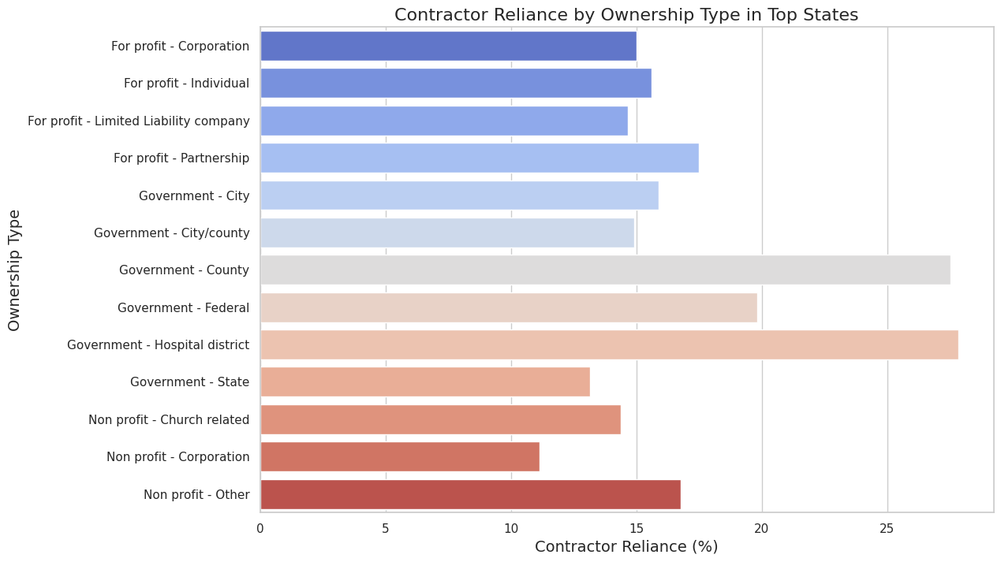

**Recommendation Three: Target Large and Very Large Facilities**

The analysis of the merged data shows that large and very large highly rely on contracted healthcare personnel. In the analysis, 19.16% of very large facilities highly depend on contracted workers, while 14.79% of large rely on contracted personnel to provide healthcare services. The scale and complexity of operating large and very large facilities contribute to the challenge of maintaining adequate fulltime employees in the facilities. Thus, Clipboard Health should take advantage of the challenges to target large and very large facilities.

Clipboard Health should focus sales efforts on large and very large government-hospital district and for-profit facilities, especially in high-reliance states and counties. The company should provide offer scalable staffing solutions to meet their changing human resource needs. For example, Clipboard Health demonstrate evidence-based case studies and testimonials to prove how it provided scalable staffing solutions to large and very large facilities in other states or counties. Therefore, Clipboard Health will establish itself as a trusted and relatable provider of staff solutions.

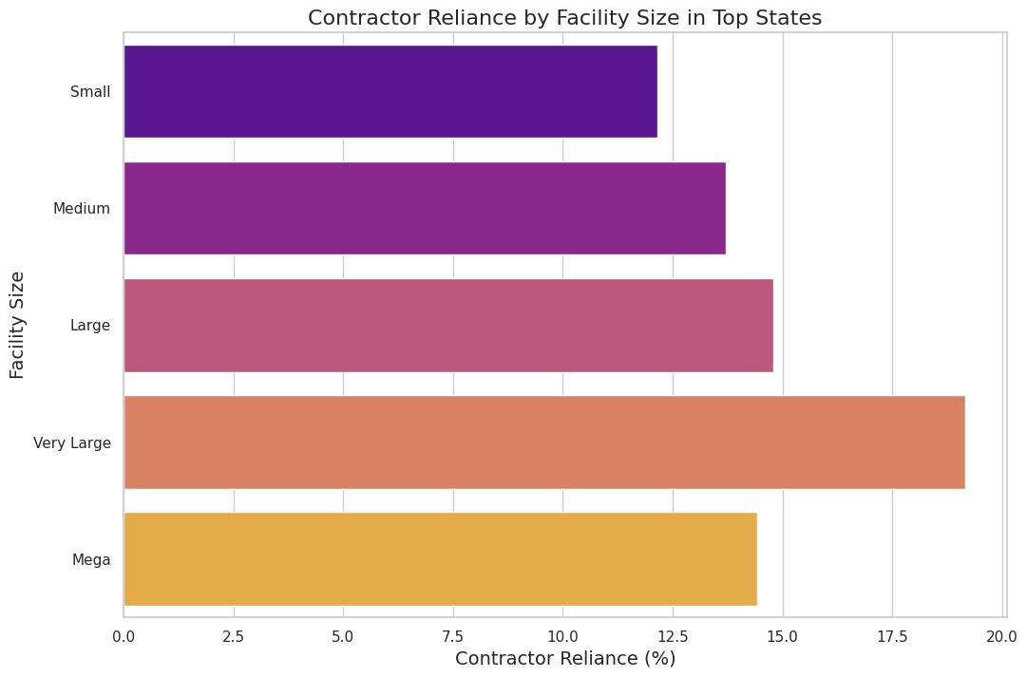

**Recommendation Four: Leverage Quality Rating to Identify Opportunities**

The analysis of the merged data shows facilities’ overall and staffing rating. It is rational to assume that facilities with staffing ratings and overall ratings of less than 2 struggle to maintain fulltime workers. In the analysis, around 7 to 8% of facilities with the highest average contractor license have low staffing rating of 1.0 or below. Therefore, the facilities with inadequate staffing levels may likely require the services of Clipboard Health to address their employee shortage with contracted workers.

In this regard, Clipboard Health should target facilities with staffing ratings of between less than 1.0 to 2.0 because they are reliant on contractors and experience the challenge of inadequate workers. The company should formulate long term partnerships with these facilities to offer them qualified and reliable personnel to address their employee shortage problems. Also, Clipboard should train contractors and onboard them to ensure they meet the facilities’ quality standards to improve their quality ratings.

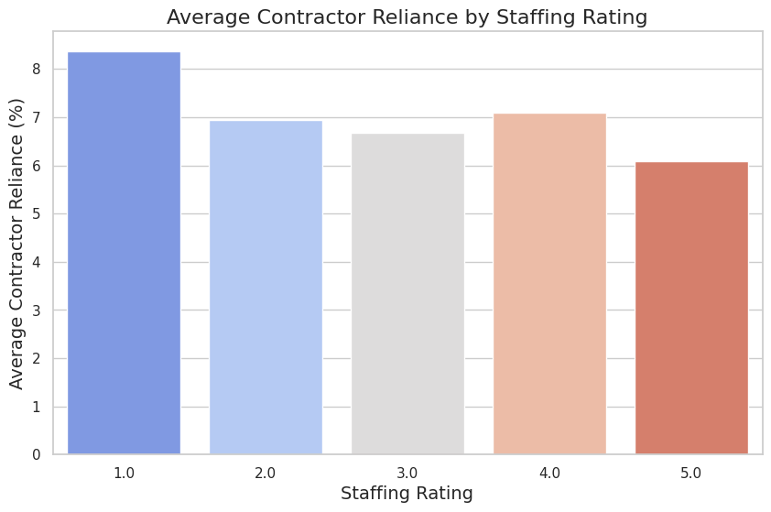

**Overall Summary**

In summary, Clipboard Health sales team should target government-owned and for-profit nursing homes that are large or very large in high-reliance states and countries. It should identify nursing homes with low staffing and quality ratings. As a result, Clipboard Health will improve its market share and address critical staffing challenges and low-quality health issues in the United States in the long term.